ICT-171

ASSIGNMENT-2 CLOUD PROJECT

**Jainil Piyushkumar Patel**

**student ID: 35480908**

**IP: 13.60.65.128**

**DNS:** [**https://medisearch.online/**](https://medisearch.online/)

* **SETTING UP A WEB-SERVER:**

1. Launch an instance

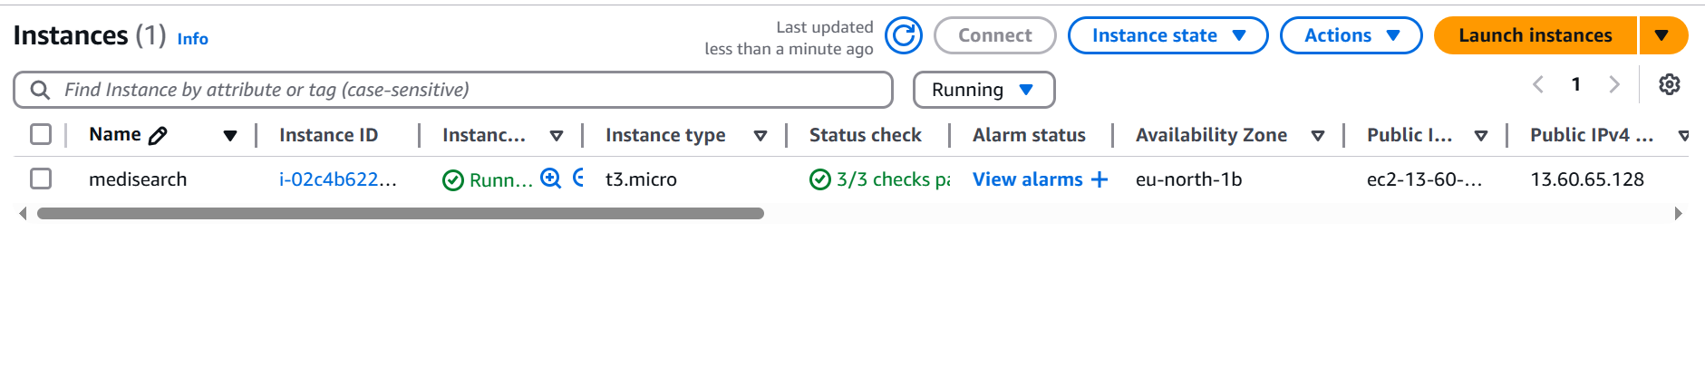

1. Enable port 22 and 80 in edit inbound rule in security option

1. Connect instance to ubuntu terminal

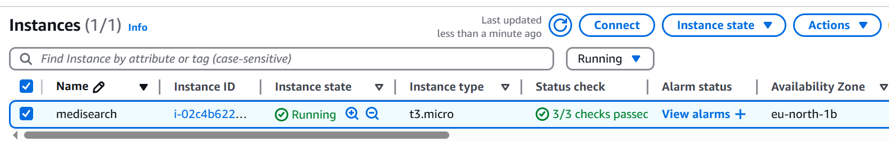

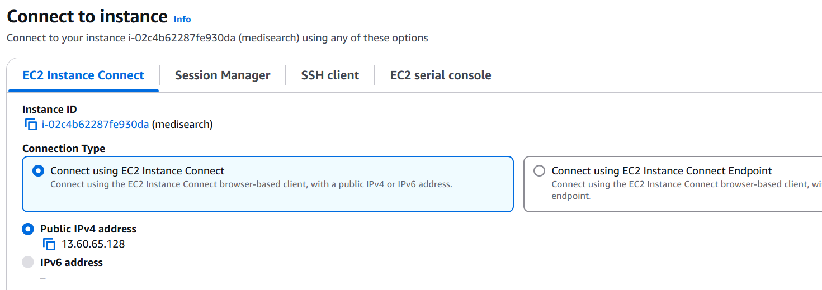

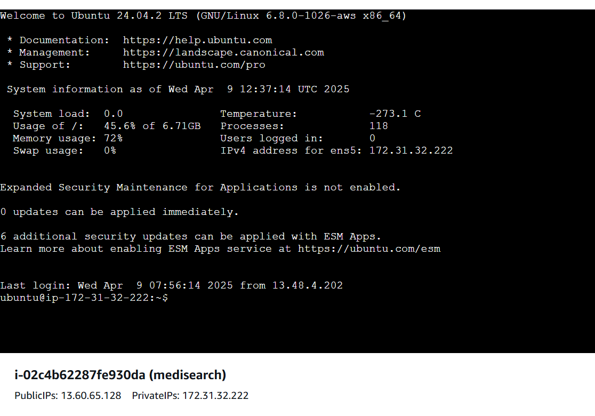

Our instance in connected with terminal

**Second way of connecting**

**1) copy chmod 400 and ssh and past it on ubuntu terminal**

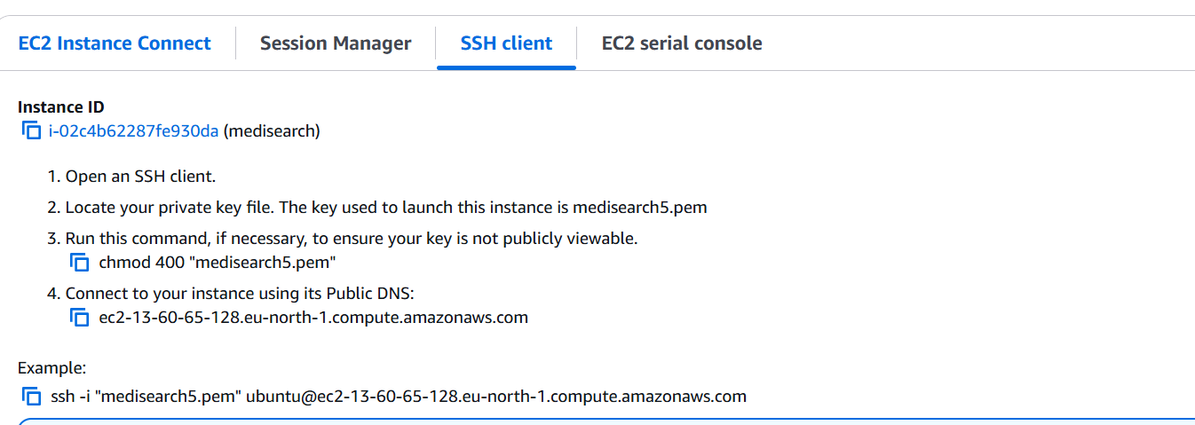

**2) and now open terminal and past it.**

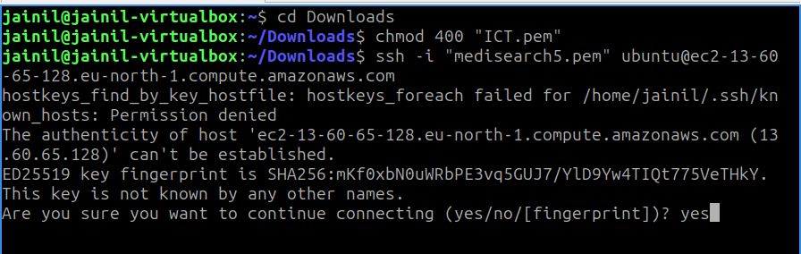

**3) and now our instance is conncted with ubuntu**

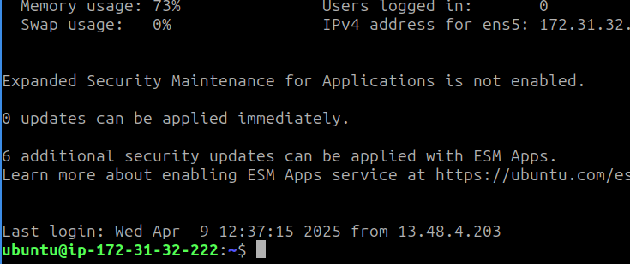

* **And now we download apache in our ubuntu:**

**Sudo apt install apache2**

**Sudo apt -get update**

**Sudo su**

**Sudo systemctl reload apache2**

**Sudo systemctl restart apache2**

* **Setting up WordPress:**
* We need to update our repository and upgrade our packages before we begin.

sudo apt update && sudo apt upgrade -y

* Install Apache server and the necessary dependency.

sudo apt install apache2 ghostscript libapache2-mod-php mysql-server php php-bcmath php-curl php-imagick php-intl php-json php-mbstring php-mysql php-xml php-zip -y

* Make the directory where we’ll host the WordPress files

sudo mkdir -p /var/www/html

* Change the directory’s ownership to the user www-data

sudo chown www-data: /var/www/html

* And then curl the zip files from the official wordpress page and unzip them into the directory we created.

curl https://wordpress.org/latest.tar.gz | sudo -u www-data tar zx -C /var/www/html

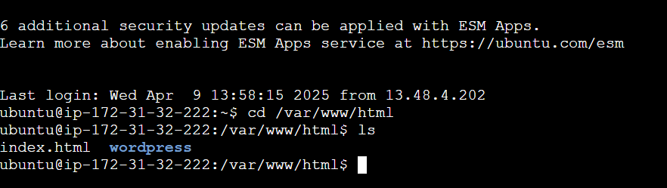

**Our wordpress is installed successfully**

**Now we can setup our account**

**Now we can login into our wordpress**

* **Linking with DNS**

1. **We create hosting network using route 53**

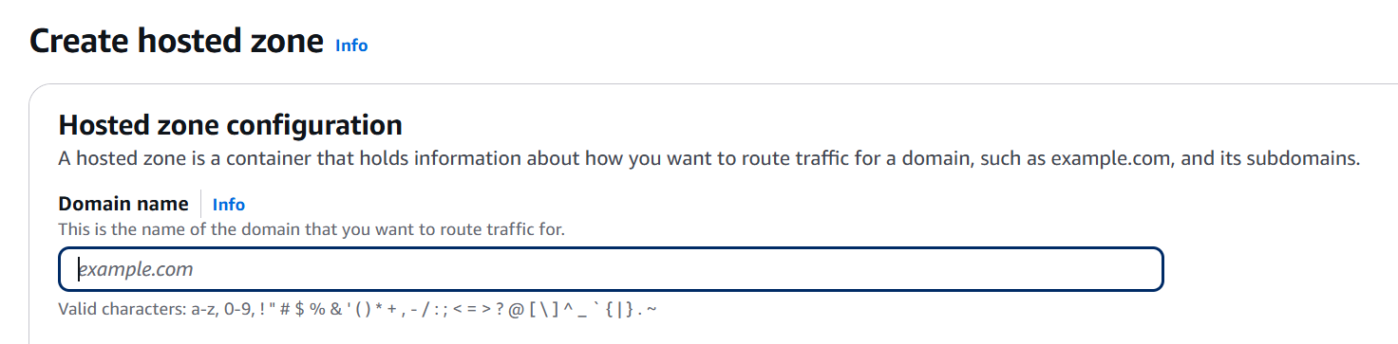

1. **Now we create an “A” record and “CNAME” record**

1. **Now we create an nameserver**

1. **Now we copy these nameservers and past into in godaddy.**

* **SSL/TLS Documentation:**

**1). First we download certbot**

sudo snap install --classic certbot

**2).**

sudo ln -s /snap/bin/certbot /usr/bin/certbot

**3).**

sudo certbot --apache

**4).**

sudo certbot certonly --apache

